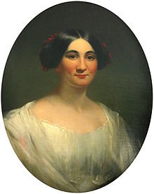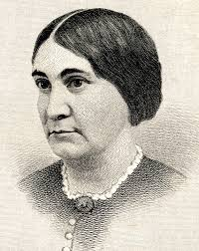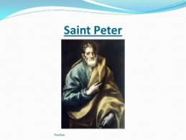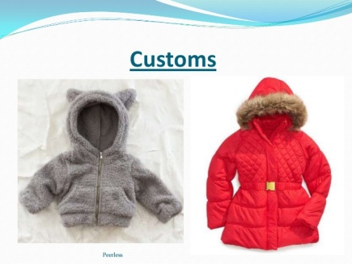
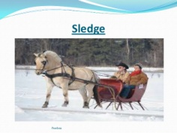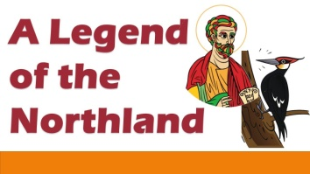

Phoebe Cary was an American poet, and the younger sister of poet Alice Cary. The sisters co-published poems in 1849, and then each went on to publish volumes of her own. After their deaths in 1871, joint anthologies of the sisters' unpublished poems were also compiled.
Born: 4 September 1822, Mount Healthy, Ohio, United States
Died: 31 July 1871, Newport, Rhode Island, United States
Nationality: American
Buried: Green-Wood Cemetery, New York, United States
Siblings: Alice Cary

A legend of the Northland
“A Legend of the Northland” is a traditional, popular story composed in the style of a ballad. It narrates the legend of how St. Peter had once cursed an old lady for being mean and stingy. The poem, thus, imparts the important lesson that greed always gets punished.
It is the story of the time when Saint Peter lived on the earth. One day he was walking about in Northland. He had kept a fast on that day. So he was weak and tired. He reached the door of a little cottage. He saw that a woman was making cakes. He requested the woman to give him a cake. She was very greedy. She did not want to give big cakes to Saint Peter. So she made a small cake for him. But she thought that it was also very big. Then she made a smaller cake for him. But she thought it was of the same size as before. So she made a very small and thin cake for him. But as she was greedy, she did not give even this cake to him. She placed it on the shelf. Saint Peter became very angry. He gave a curse to the lady to have come to a bird.
A legend of the Northland’ is a ballad. A ballad is a poem narrating a story in short stanzas. Ballad is such kind of poem which tells a story in short stanzas and in the poem all the stanzas comprise four lines. In total, there are 16 stanzas in this poem and these stanzas will tell us a story. Ballads are a part of folk culture or popular culture and are passed on orally from one generation to the next. (Folk culture is a story of any area and is known as ballad). Folk culture comprises of traditional stories which are passed on from one generation to next generation.
This story is of the Northland area, the area which is near the North Pole. This exact place is not specified but ‘Northland’ means the area in the northernmost part of the earth i.e., near the North Pole. ‘Legend’ means a historical story, one which is very old and has been passed on from generation to generation.

